Gary Andreas 2311533004 Informatika

**Tugas Pekan 8**

1. 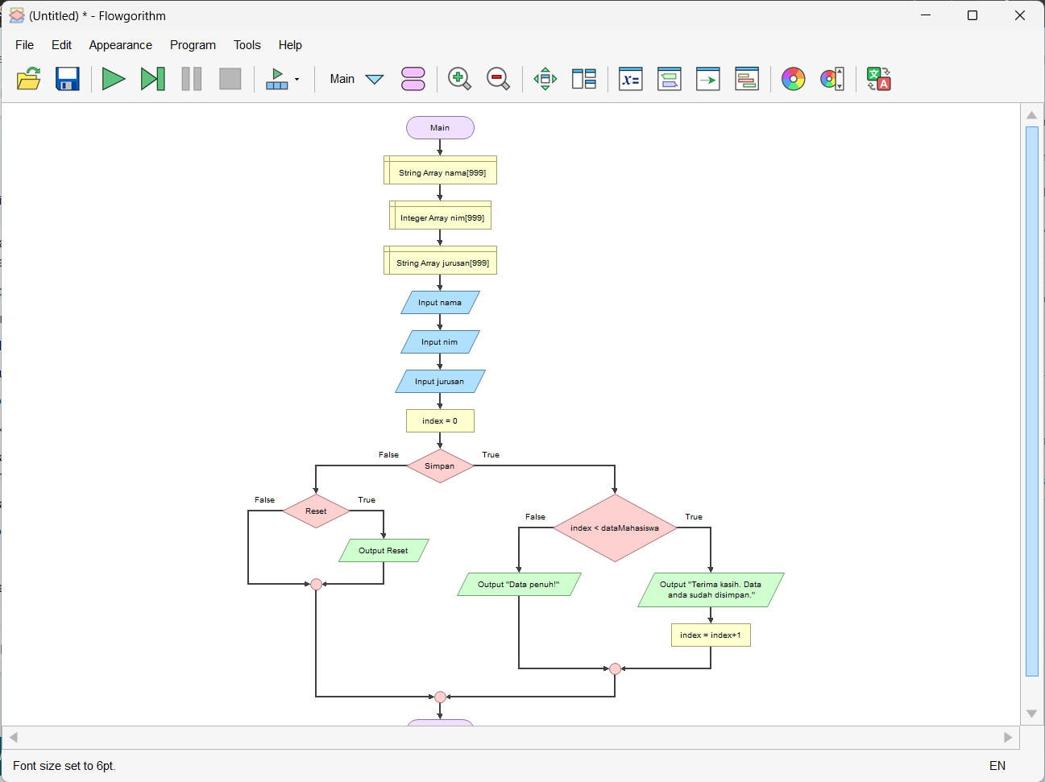Flowchart
2. 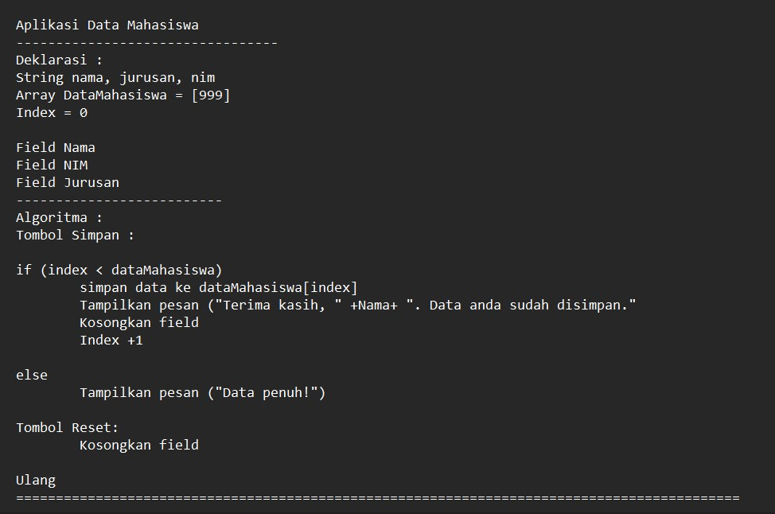Pseudocode